Advanced Algebra 2

NOTES 1.2: Unit 1 Lesson 2: Parent functions and their key attributes

Objective: I will be able to graph the parent functions and analyze key features: Domain, Range, Intercepts, Symmetries, Maximum and Minimum given an interval.

Intercepts:
We will explore x and y intercepts for functions:

The x-intercepts are the points of the graph that cross the x-axis.

They will always be written as ordered pairs: $(x, 0)$ Note that y = 0 ALWAYS

The y-intercept is the point of the graph that crosses the y-axis.

It will always be written as an ordered pair: $(0, y)$ Note that x = 0 ALWAYS

Also note that a function can have multiple x-intercepts, but only 1 y-intercept.

Symmetries:
A function can have y-axis symmetry, origin symmetry or no symmetry.

Y-axis Symmetry:
Functions that have symmetry about the y-axis are called EVEN functions.
This means that if you were to fold the graph along the y-axis, the two halves would perfectly overlap.

Origin Symmetry:
Functions that have symmetry about the origin are called ODD functions.
This means that if you rotate the graph 180 degrees about the origin, it will look exactly the same.

Extrema:
The extrema are the maximum and minimum values of a function.

Absolute Maximum (also called global) is the single highest point on the entire graph of a function.
Absolute Minimum (also called global) is the single lowest point on the entire graph of a function.

Relative Extrema (also called local) is a point on the graph where the function has a maximum or minimum value relative to the points in its immediate vicinity. In other words, the max and min within a specific interval.

Because these are points, they will be designated using ordered pairs.

Example 1:
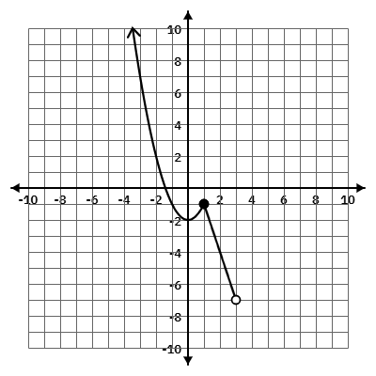
For the function below, provide all requested information.

X-intercept:

Y-intercept:

Relative Max for the interval [-3, 2]:

Relative Min for the interval [-3, 1]:

Type of Symmetry:

Domain in
Inequality:
Set:
Interval:

Range in
Inequality:
Set:
Interval:

Parent Functions we will study in this unit include:
X-intercept: Y-intercept:

Type of Symmetry:

Relative Max:

Relative Min:

Domain and Range in
Inequality Notation:

Set Notation:

Interval Notation:

$f(x)=x$ ________________________

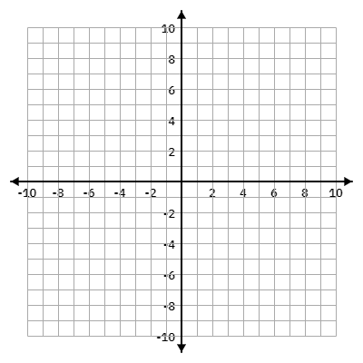

X-intercept: Y-intercept:

Type of Symmetry:

Relative Max:

Relative Min:

Domain and Range in
Inequality Notation:

Set Notation:

Interval Notation:

$f(x)=x^{2}$ ___________________________



X-intercept: Y-intercept:

Type of Symmetry:

Relative Max:

Relative Min:

Domain and Range in
Inequality Notation:

Set Notation:

Interval Notation:

$f(x)=\left|x\right|$ ________________________


$f(x) = \sqrt{x}$ _______________________
X-intercept: Y-intercept:

Type of Symmetry:

Relative Max:

Relative Min:

Domain and Range in
Inequality Notation:

Set Notation:

Interval Notation:



